Module Name: environmental configuration
Test case ID:TC_01
Webpage URL:www.selenium.com

Scenario ID : 1

Test steps:
python installation successfully

Screenshots:

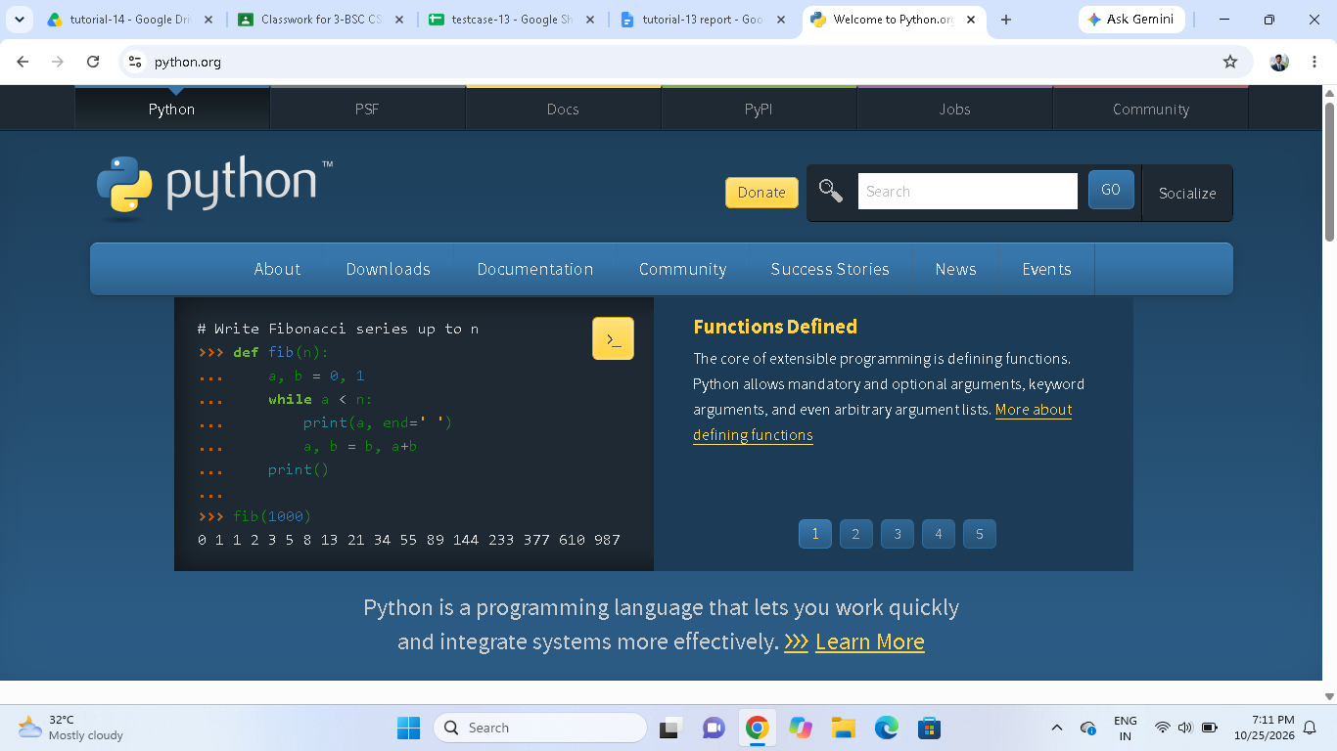

Scenario ID : 2

Test steps:

selenium installation successfully

Screenshots:

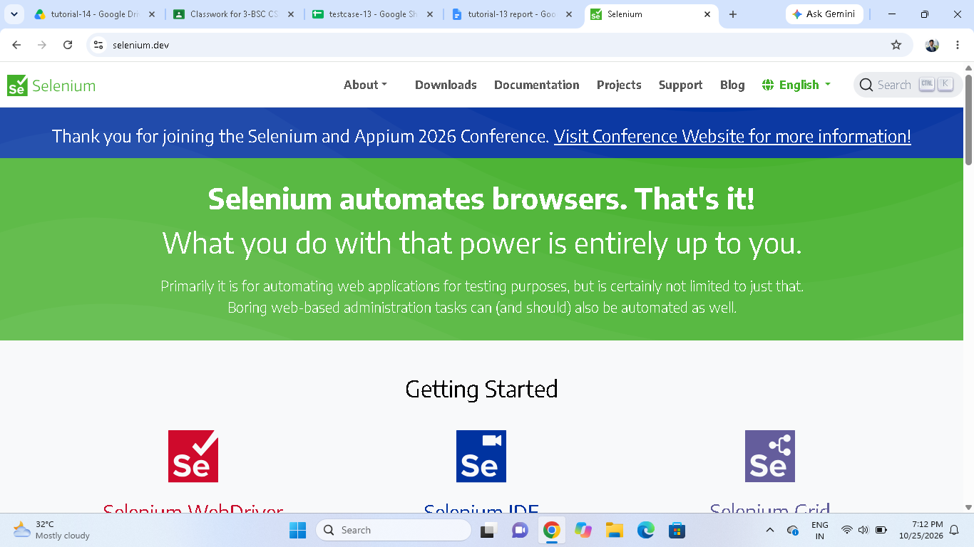

Scenario ID : 1c
Test steps:
browser launches successfully

Screenshots:
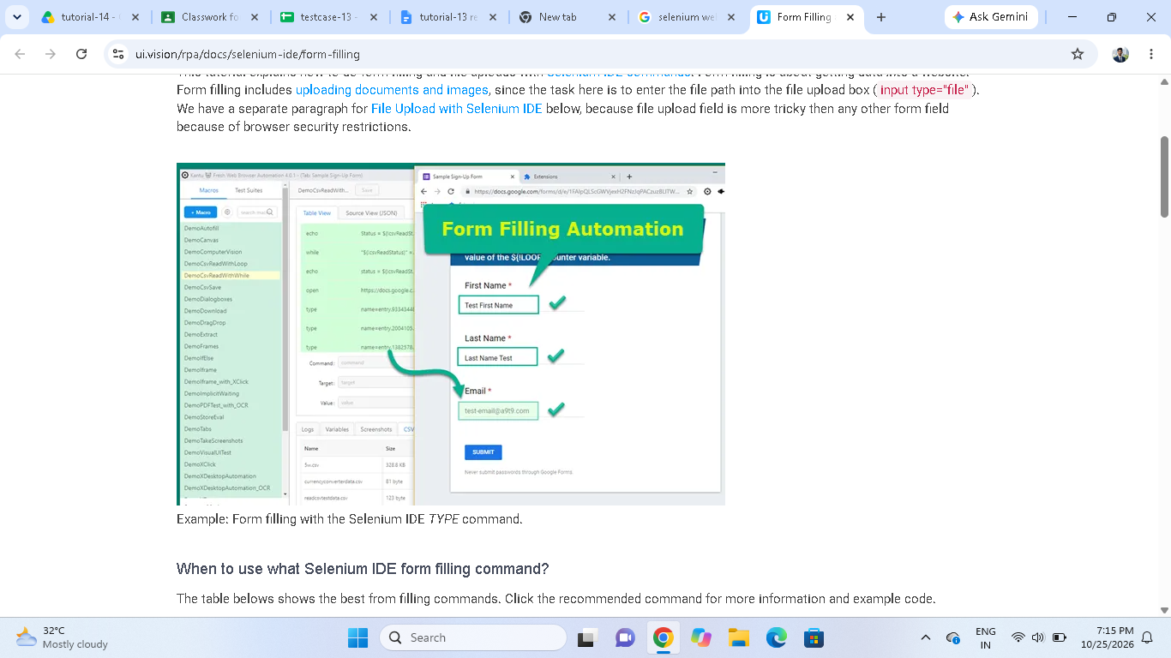
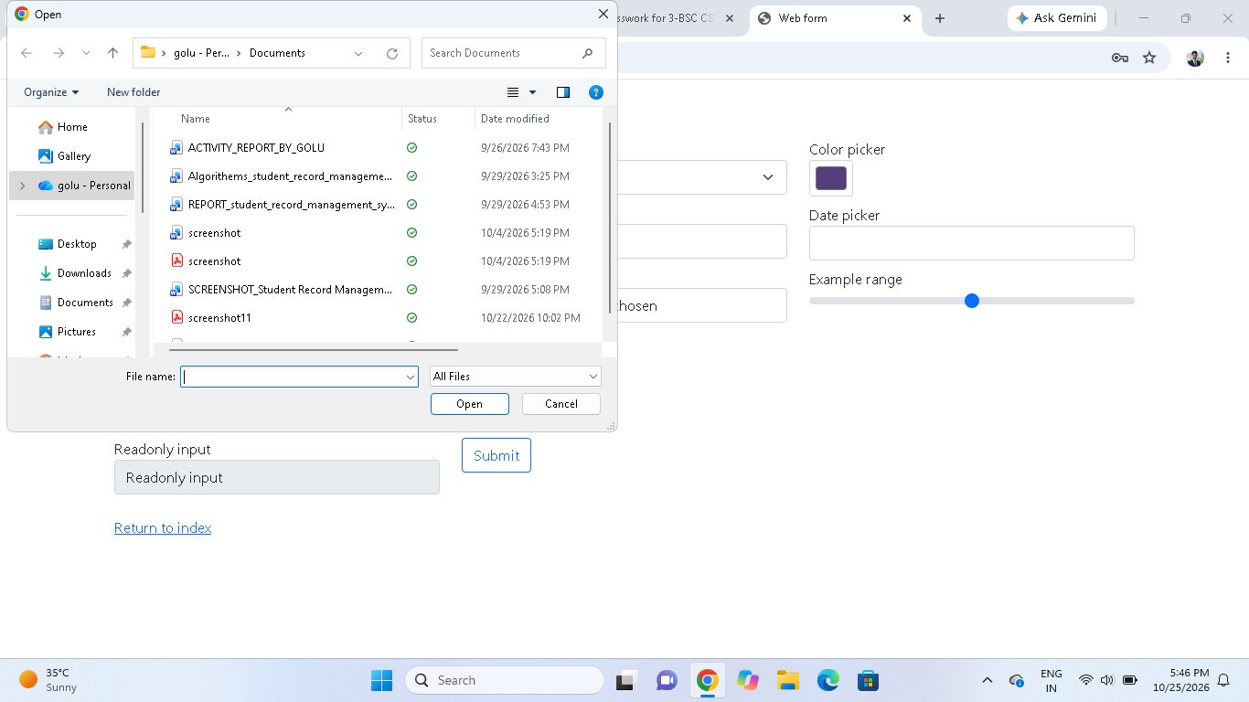

Scenario ID : 1d
Test steps:

selenium web form open successfully

Screenshots:

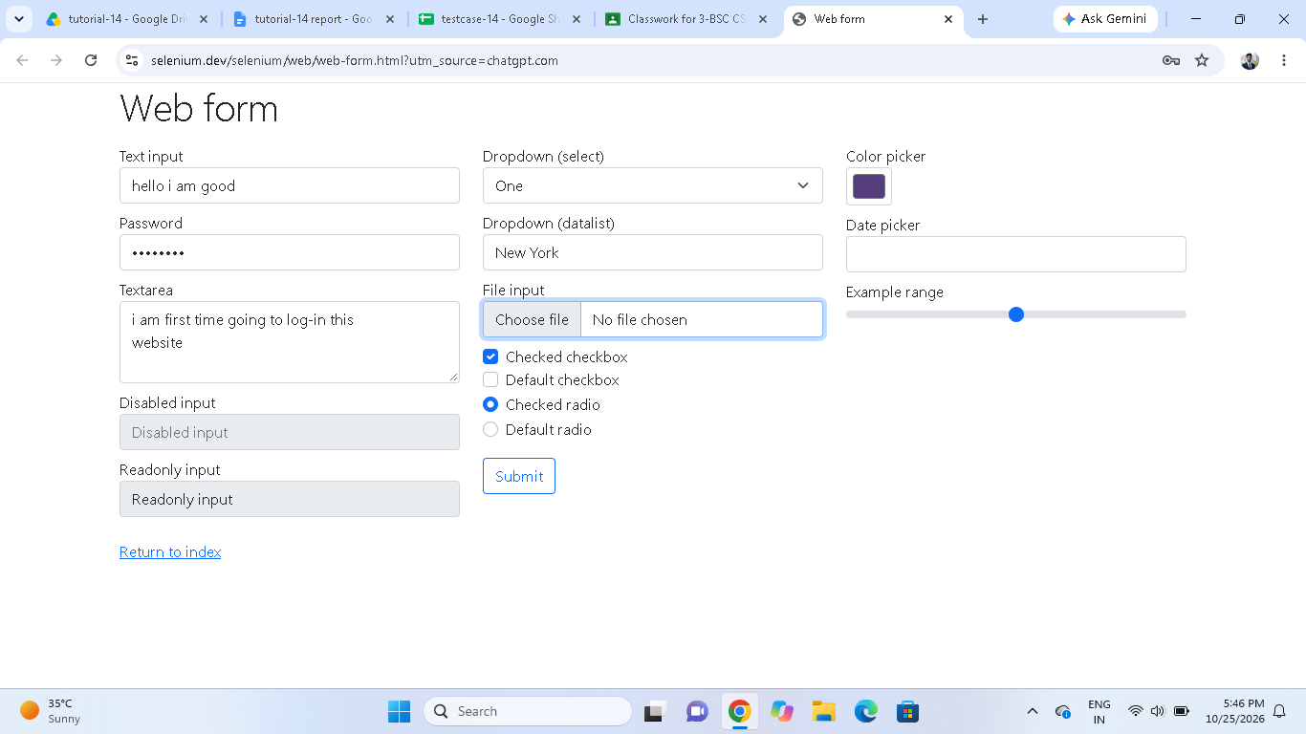

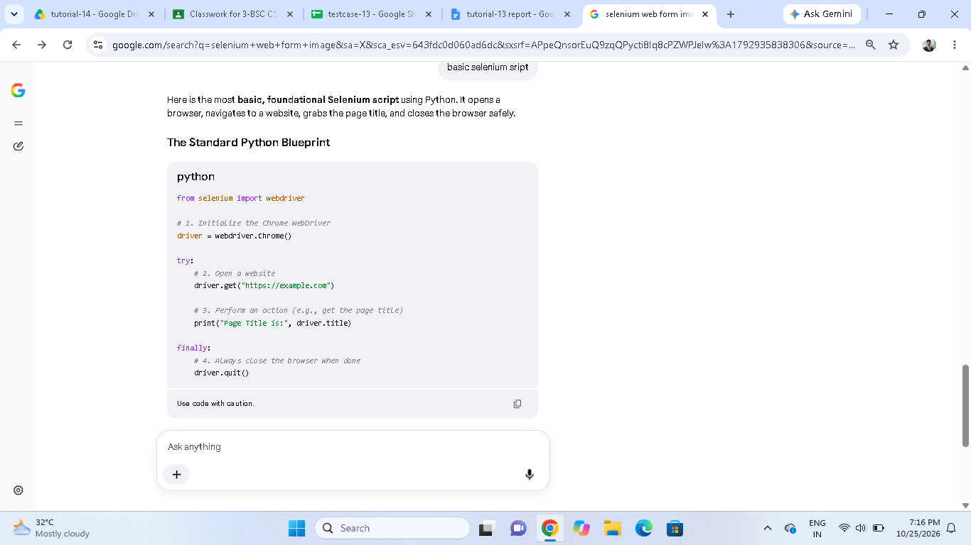

Scenario ID : 1e

Test steps:

basic selenium script executes

Screenshots:

